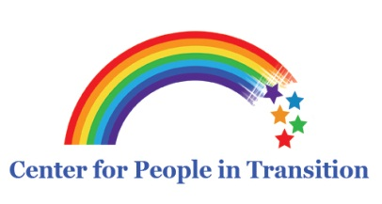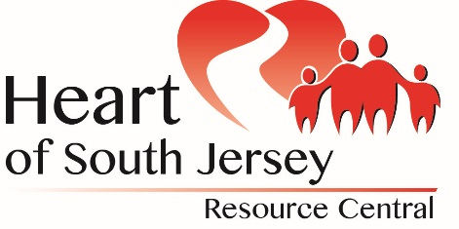

EIRC—SENIORCORP—VOLUNTEER CENTER—CENTER FOR PEOPLE IN TRANSITION—CLAYT0N PUBLIC SCHOOLS—
CENTER FOR FAMILY SERVICES—PEOPLE FOR PEOPLE
What Employers Expect from their Employees in the 21st Century
Wednesday, August 17, 2016 6:00–8:30pm
On Campus of Rowan College at Gloucester County
1400 Tanyard Road Sewell NJ 08080
Are you one of the lucky individuals who landed the job? Are you one of the frustrated individuals who has sent your resume to hundreds of employers and perhaps even got the interview but still was not hired? Whether employed, seeking employment now or in the future, it is so important to know employers’ expectations. Getting the job is a fantastic feat, BUT knowing the keys to keeping the job is a life skill that must be practiced daily in the work place. Come join us for this workshop and learn what is acceptable and what is unacceptable in the workplace in the 21st Century.
Nancy Howard, M.S., Human Resource Management
To register, please call People in Transition at
856-415-2222 or email peopleintransition@rcgc.edu

