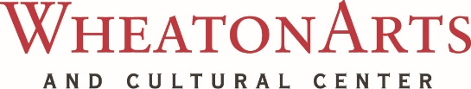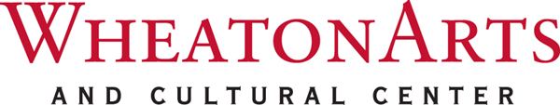**CONTACT:** Cathy Nolan, Chief Operations Officer

**TEL:** (856) 825-6800, ext. 115 **/ FAX:** (856) 825-2410

**E-MAIL:** wheatonartsnews@wheatonarts.org

**WHEATONARTS PRE-HANUKKAH MENORAH LIGHTING**

**MILLVILLE, NJ (November 30, 2017) –** Join the Jewish Federation of Cumberland, Gloucester & Salem Counties as they sponsor the annual *WheatonArts Pre-Hanukkah Menorah Lighting* in celebration of Hanukkah’s “Festival of Lights”. The event takes place on Sunday, December 10 at 11:30 a.m. in the Glass Studio at WheatonArts with the lighting of a colossal sized, handcrafted, glass menorah. Refreshments, music, crafts, and a dreidel competition will accompany the event, providing fun for the entire family.

This unique experience into the Jewish cultural tradition is open to the public, reservations are recommended. For more information about the *Pre-Hanukkah Menorah Lighting*, call the Jewish Federation of Cumberland, Gloucester & Salem Counties at 856-696-4445. For more information about WheatonArts’ programs, call 856-825-6800 or visit wheatonarts.org. WheatonArts is open Tuesday through Sunday, 10 a.m. to 5 p.m., April through December. Closed Christmas Day and New Year’s Day. WheatonArts’ Museum Stores are open seven days a week through December 31, 2017.

WheatonArts strives to ensure the accessibility of its exhibitions, events, and programs to all persons with disabilities. Please provide two weeks notice of additional needs. Patrons with hearing and speech disabilities may contact WheatonArts through the New Jersey Relay Service (TRS) 800-852-7899 or by dialing 711.

Funding has been made possible in part by the New Jersey State Council on the Arts, a Partner Agency of the National Endowment for the Arts, the Geraldine R. Dodge Foundation, the National Endowment for the Arts and the New Jersey Cultural Trust. WheatonArts receives general operating support from the New Jersey Historical Commission, Division of Cultural Affairs in the New Jersey Department of State, and is supported in part by the New Jersey Department of State, Division of Travel and Tourism.

______________________________________________________________________________

**About WheatonArts**  
WheatonArts and Cultural Center, founded as Wheaton Village in 1968, is a nonprofit 501(c)(3) organization with a mission to **engage artists and audiences in an evolving exploration of creativity. The mission will be advanced through the interpretation of collections and exhibitions; education initiatives and culturally diverse public programs; residencies and other opportunities for artists.** With a history spanning four decades, WheatonArts has earned regional, national and international recognition for its unique collections and programs. The Museum of American Glass is at the heart of the Center, housing the most comprehensive collection of glass produced in America - from the first glass bottles made in America to celebrated works by Dale Chihuly, Paul Stankard, and other contemporary artists who work in glass. Visitors experience the art of glassmaking, ceramics and flameworking in the Artists Studios. From April through December the Museum of American Glass and Gallery of Fine Craft present special exhibitions. WheatonArts also offers traditional and multi-cultural programs, classes, workshops, performances, and weekend festivals. The award-winning Museum Stores offer traditional and contemporary art and craft in all mediums.

**About Jewish Federation of Cumberland, Gloucester and Salem Counties**

Jewish Federation of Cumberland, Gloucester, and Salem Counties assumes an active leadership role in the cultural, educational, philanthropic, religious, social and social welfare needs of Jews living in Cumberland, Gloucester, and Salem Counties. Guided by the mitzvot of tzedakah (charity), chesed (loving-kindness) and Tikkun Olam (repairing the world), They promote Jewish culture and heritage in the region and advocate for national and global Jewish interests, with a special focus on Israel and vulnerable Jewish populations around the world.